# **If you want to edit join UQAttic group.**

**Don’t email me requesting access, read the instructions below.**

# **CSSE2310: 2020 SEM1 exam answers**

## [**UQAttic**](http://uqattic.net)

## **Get more out of your study time. Join UQAttic's revision chat.**

#### [**Other exam papers**](https://drive.google.com/drive/folders/1k04K5RHL61k3ae2jJ362MPdN5xy3Bqsp)

### Please **contribute** to these documents.

### If you're looking for an effective way to familiarise yourself with the course material, you can't go past collaborating with fellow students. We have laboured to put these up, and so at the very least point out where you think we are wrong!

### You'll get more out of the course, you'll do better in the exam, and other students will benefit from your input as well.

### To get editing permissions, simply go to the [chatroom](http://uqattic.net) and provide us with your Google Account address.

### **Style.**

### Type answers in blue beneath each question.

### If you're unsure of your answer, highlight your answer text then hit Ctrl+Alt+M to create a comment beside the text. Once you're satisfied with the answer, click the "Resolve" button on the comment.

### If you want some extra explanation from someone else on their answer, highlight the other person's answer and repeat the procedure above.

### **Communicate.**

### Head over to [uqattic.net](http://uqattic.net/) and click "Chat Now!". You'll find a chatroom full of students just like you. Talk about a revision document (like this one) or swap prep tips. If you have your own IRC client, point it to irc.uqattic.net, port 6667, channel #attic.

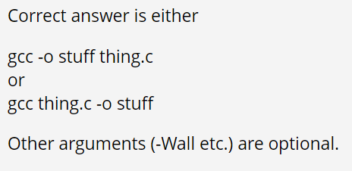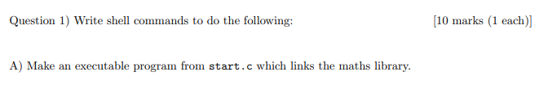

gcc start.c | -lm

gcc -lm start.c ??? [+2]

gcc start.c -lm // -lm needs to go last

No it doesn't have to go last, an example of this can be seen in the test submission of 2021 Sem 1 ^



Cat bill | tail -3 [+1]

tail bill -3 // don’t need cat in any (most?) of these

tail bill -n 3

In terminal these are invalid, need -3 first

tail -3 bill, or cat bill | tail -3 [+1]

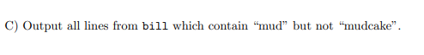

Cat bill | grep mud | grep -v mudcake

Grep mud bill | grep -v mudcake



Cat bill | cut -d ‘ ‘ -f 4

t



Cat bill | grep cake | sort -r [+1]



Svn rm pots.c fairly certain svn delete is what should be used rather than svn rm

Svn commit

[+1]



Gcc pond.c 2> logs.err

I think it might be gcc pond.c 2>> logs.err since it says ‘append’ [+3]

Dont you have to add -c since it just asked to compile so: gcc -c pond.c 2>> logs.err [+2]



Gcc -o box dims.c space.c [+2]



Ls *?.cc [+2] <- This is all .cc files except those with one character before ‘.cc’ - ls ????*.cc [+1]



Svn add dims.c

Svn add space.c

Svn commit

Svn commit dims.c

Svn commit space.c

? thought the question assumes that they’ve already been added

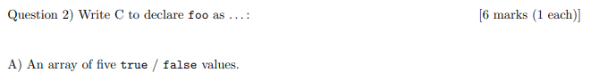

bool foo[5]; [+1]



char* foo[10]; [+1]



Short (*foo)(char c);

I don’t think you’re supposed to specify the parameter’s name in a function pointer so it would be:

short (*foo)(char); [+3]



Volatile int* foo;



Const char* foo; [+1]



Long double foo; [+1]

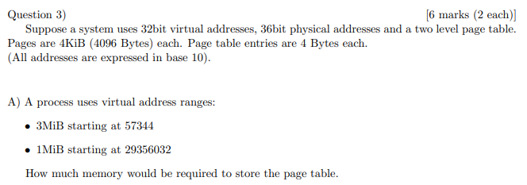

16 KiB

Dont both files use the same top level page? Therefore only 3 pages - 12 KiB

4KiB/4 = 1024 page table entries per page table

57344/4KiB = #14

57344 + 3MiB -1 ~~(minus 1 because adding 3 MiB will bring us to start of next memory block) = #781~~

57344 and 3MiB takes up 1 pages (0-1023)

29356032/4KiB = #7167

29356032 + 1MiB -1 = #7422

Takes up 2 pages (6144-7167 & 7168-8191)

2 pages +1pages + one more page (for top level page) = 4 pages total.

4*4KiB = 16 KiB

3Mib = 768 pages which starts at 14 therefore 14 + 768 = < 1023 thus 1 page

1Mib = 256 page 7167 + 256 = 7423. 7167 at end of page thus 2 pages

Plus 1 for top level = 4 pages there 16Kib

Background info:

4KiB/4 = 1024 page table entries per page table

A.1:

Starts @ 57344 which when divided by pagesize comes to loc. 57344/2^12 = 14th add.

Size is 3 MiB so 3 x 2^20 / 2^12 = 786 additional entries.

Since 786+14 (=800) < 1024 in the first page of the second level page table, the address space does not span more than 1 second-level address table.

Therefore total memory required: 1 (first level) + 1 (second level) x page size = 2 x 4Kib = 8Kib

A.2:

Starts @ 29356032 which when divided by pagesize comes to loc. 29356032/2^12 = 7167th add. (this is the very last address of the 7th second-level page table).

I didn’t bother with the size, since I knew 1MiB < 3MiB the address space would span across to the 8th second level page table and not continue past that (because it would be less than 786 entries). Therefore 2 pages needed to store

Therefore total memory required: 1 (first level) + (2 + 1) (second level) x page size = 4 x 4Kib = 16Kib

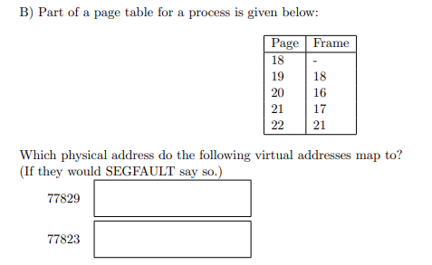

77829: 73733 [+3]

77823: SEGFAULT [+3]

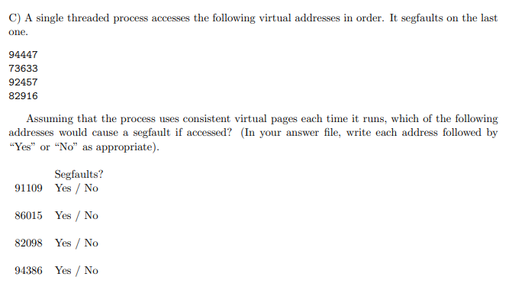

82916/2^12 = page 20

91109: page 22 => NO

86015: page 20 => YES 86015/4092 gives a page of 21, not 20, so it would be no, right?

820998: page 20 => YES

94386: page 23 => NO

*question is essentially asking you to form a page table with the numbers at the beginning of q, and compare with the VA addresses to see if segfault. The middle two will segfault because 82916 segfaults and has the same pagenum

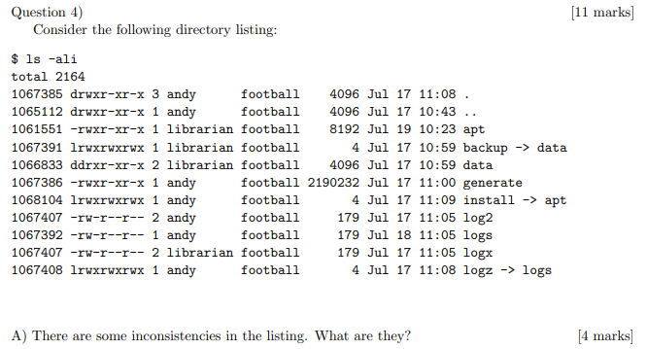

Link count for parent dir [+1]

As this question is for marks, could this be split into parent links <3 and parent links < subdirectory links (1 < 3)

Owner for hard link log2<->logx [+2] (hardlink not a cod perk...)

Dd in permissions -can’t have [+2]



ln -s data backup [+2]

I don’t think you’re supposed to specify the file name



Chmod 721 install

Chmod g-x apt [+1]

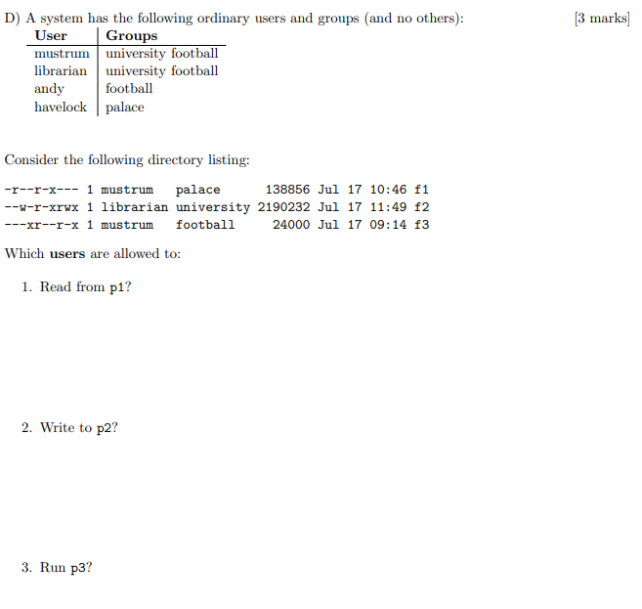

f1=>mustrum and havelock [+1]  
f2=>mustrum (librarian, andy, havelock)?[+6] and not mustrum

How can librarian write without read?

I think Only **havelock and andy** can write

You can write to a file that you have no permissions to read

f3=>mustrum and havelock [+1]

Mustrum, librarian, havelock [+1]

The more specific permissions take precedence over the less specific (therefore the precedence is as follows: individual, group, public). So in this case, **mustrum and havelock** are the only ones that can execute. No one in “football” can execute p3. [+1]

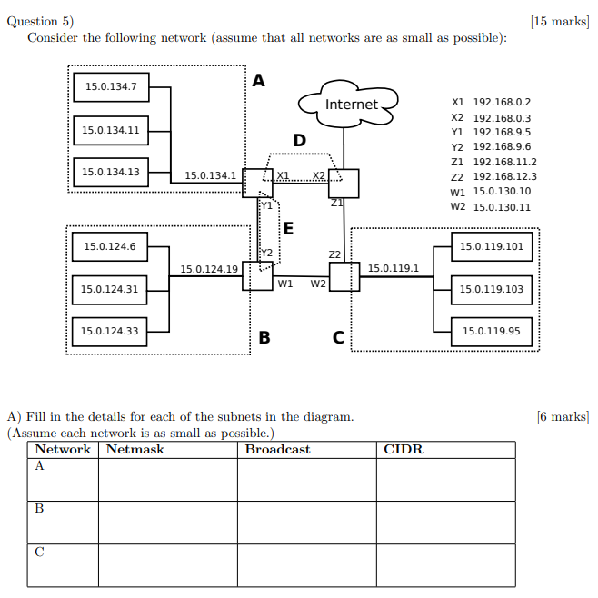

A: 255.255.255.240, 15.0.134.15, 15.0.134.0/28 [+2]

B: 255.255.255.192, 15.0.124.63, 15.0.124.0/26 [+2]

C: 255.255.255.128, 15.0.119.127, 15.0.199.128/25 (15.0.199.0/25? [+5])

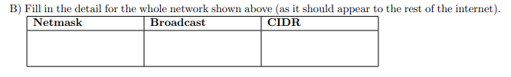

255.255.0.0, 15.0.255.255, 15.0.0.0/16.Use all the publicly available networks [+2]

HOW??? Pretty sure it's how the question is worded, as it would appear to the rest of the internet which means we don't include any private networks. 192.168 ip addresses are private so we don't include them

15.0.130.10 00001111.00000000.10000010.00001010q

15.0.130.11 00001111.00000000.10000010.00001011

15.0.134.1 00001111.00000000.10000110.00000001

15.0.119.1 00001111.00000000.01110111.00000001

15.0.124.19 00001111.00000000.01111100.00010011

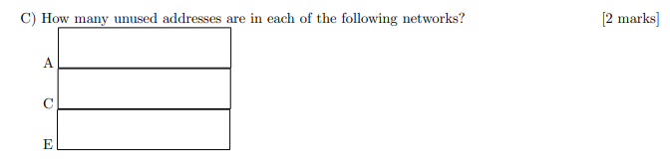

A- 10 [+1]

C- 122

E - 4 or is it 0? I think 0 too [+6]

How? I don't think 0 is right because you are assuming the CIDR is 192.168.9.5/31 but i checked on an ip range site and it says the range for that CIDR is from 192.168.9.4 to 192.168.9.5 please let me know if you think otherwise

This doesn’t make sense to me, as 5=101 and 6=110 so there are 3 host bits, so 3^2-2(broadcast, network) - 2 (hosts) = 4?

I think its 0 because it looks like theres 2 host bits: [+1]

192.168.9.00000110

192.168.9.00000101

Hence bits are common up until 30th bit, so 2^2 -2 -2 = 0



8 [+3]

1. A network with 128 addresses requires 7 bits (2^7).

However, 2 addresses will always be reserved, thus, we need another bit (+1) MINIMUM to meet 128. Thus, we need 8 bits.

1. The number of host bits is 11 (32 - CIDR or 32 - 21).
2. Subtracting the number of addresses from the number of host bits will get you 3 bits. (11 - 8)
3. 2^3 = 8.

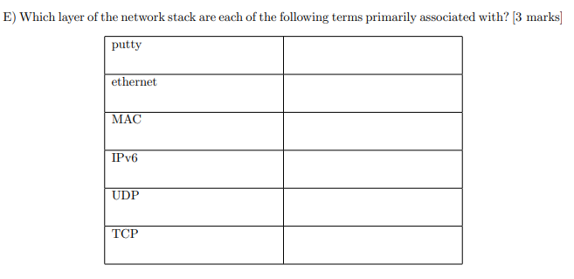

5,2,2,3,4,4 [+4]

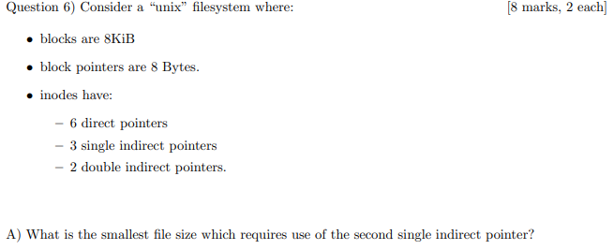

3194880 Bytes? no (-1)

8192/8 = 1024p/block

6 + 1024 = 1030 blocks

1030 * 8 = 8240KiB [+4]

Not 1031 * 8 = 8248KiB?? Or 8241KiB? {+2}

***Not 1030 * 8KiB + 1 = 8437761??? [+1] Think it is this one https://edstem.org/au/courses/6295/discussion/682498***



(6 + (2^10 * 3) + (2^20 * 2)) * 8KiB = 16801840KiB [+6]



Net difference = -filesize of double indirect + filesize of triple indirect

= - 2^10KiB + 2^20KiB = 1047552KiB

It’s not asking for the difference

New max filesize = 16801840KiB + 1047552KiB = 17849392KiB???

2^13*(6 + 3*1024 + 1024^2 + 1024^3)/1024 = 8598347824 KiB [+8]



Is it just one as it’s cached in ram??? - Only need direct pointer = 1 [+1]

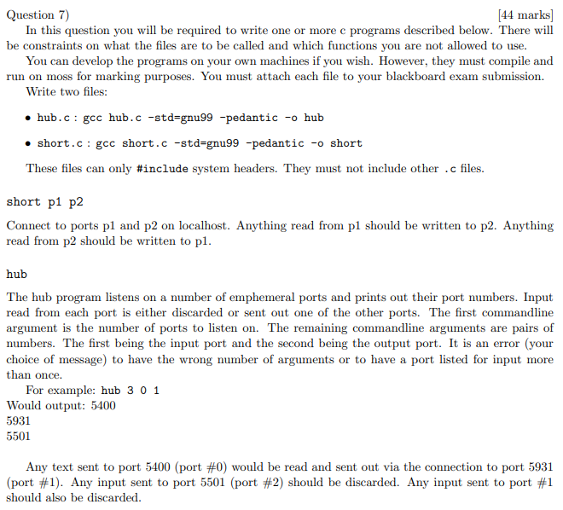

ANSWER THIS

The 2021 S2 exam will not have questions as hard as this, as we do not have a compiler/it is not online. Look at papers pre-covid for more realistic difficulty.